Nice LFMN – Nice LFMN

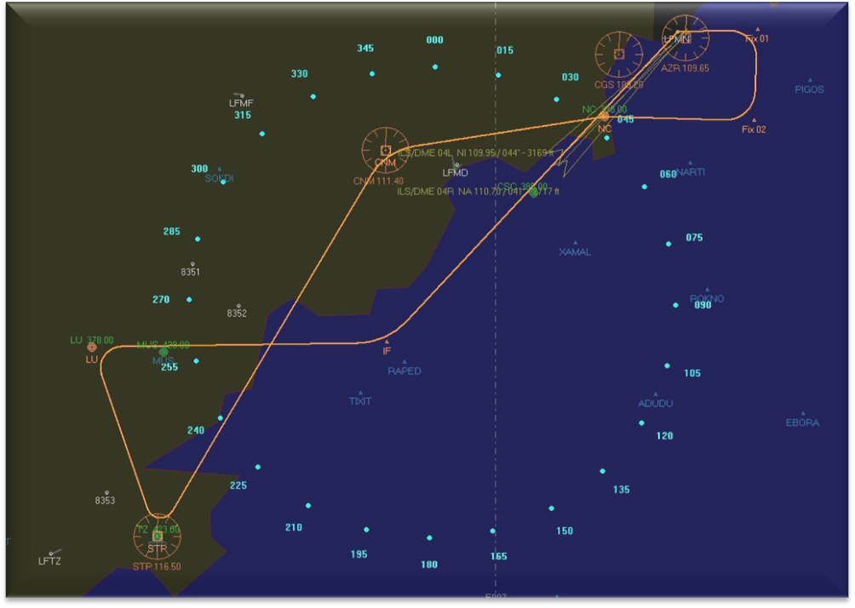
Code | Name | Type | Freq | Course | Dist
Fix 01 | Fix 01 | Fix |  | 088 | 0004
Fix 02 | Fix 02 | Fix |  | 182 | 0005
NC | NICE | NDB | 338.000 | 272 | 0008
CNM | CANNES TANNERON | VOR | 111.400 | 261 | 0011
STP | ST.TROPEZ | VOR | 116.500 | 210 | 0024
LU | LE LUC | NDB | 378.000 | 342 | 0011
IF | IF | Fix |  | 089 | 0015

LFMN Nice/Cote D'Azur (Nice/Cote D'Azur France)
Latitude: | N43* 39.91', 43.66524 | Longitude: | E007* 12.90', 7.215042

Elevation: | 000010.00 | Magnetic variation: | E 00

Frequencies:

 |  |  |  |  | ATIS: | 129.600

 |  |  |  |  | Ground: | 121.775

 |  |  |  |  | Delivery: | 121.700

 |  |  |  |  | Tower: | 118.700 121.275 121.875

 |  |  |  |  | Approach: | 120.850 122.925 124.175 125.575 130.825 134.475

ILS Information:

04R - ILS/DME 04R - NA - 110.700 - (Glideangle: 03.00 - Rwy length: 09713 ft)

04L - ILS/DME 04L - NI - 109.950 - (Glideangle: 03.50 - Rwy length: 08425 ft)

Runway Information:

04L - Heading:044 - Length:08425 - Width:148

22R - Heading:224 - Length:08425 - Width:148

04R - Heading:044 - Length:09713 - Width:148

22L - Heading:224 - Length:09713 - Width:148

